# MIS6323 – Project 3: Sample Run

Submitted by: Debarati Saha (dxs166430)

* Entered a 11-digit number:

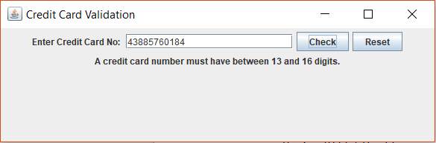

* Entered a 16-digit number starting with 9:

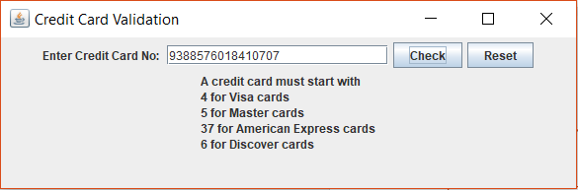

* Entered a valid number separated by “/”:

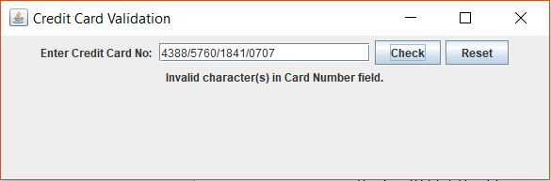

* Entered a valid Visa card number separated by “-“:

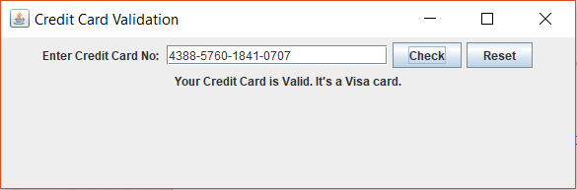

* Entered a valid Mastercard number separated by space:

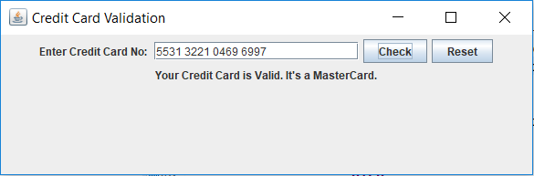

* Entered an invalid number:

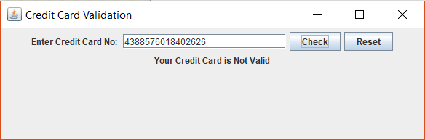

* Pressing reset button cleans the text field and feedback field.

